# **Caremark.com - Account Balance and Payments Website**

|  |
| --- |
| **Scenario/Member Statements** |

I received a bill with my order, but I lost it. Can I find the balance on the website?

There should be a credit on my account, where can I find that?

|  |
| --- |
| **View Mail Service Account Balance Caremark.com Members** |

1. Have the Member select Profile.

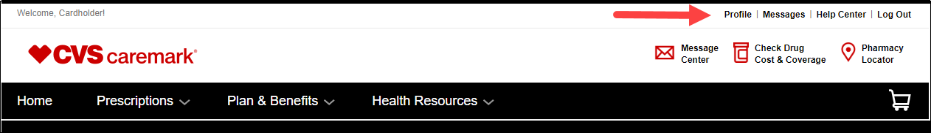

1. Have the Member select Balance and Payment.

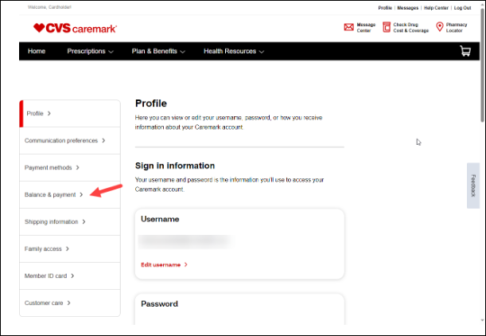

1. The Balance and payment screen will display. If a balance is due, or a credit available it will display.

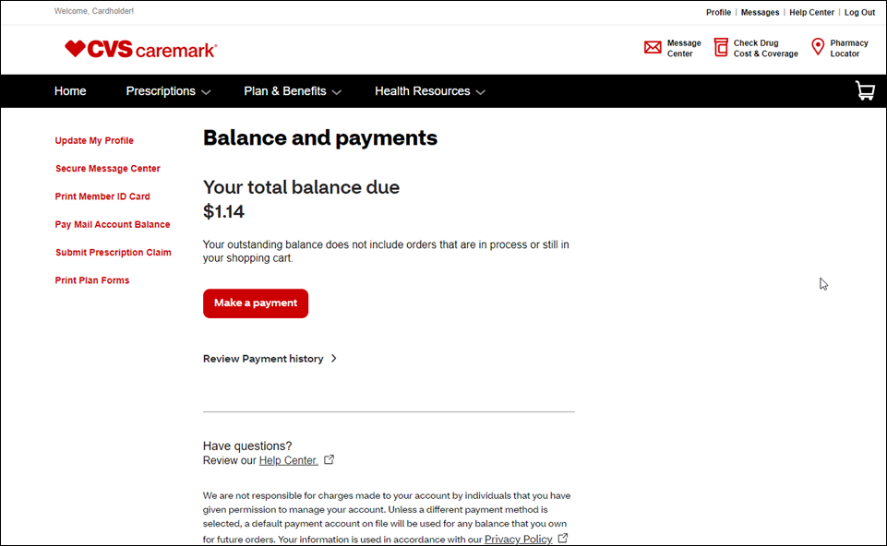

|  |
| --- |
| **Updating/Adding Payment Options** |

1. Click **Profile** in the upper right corner of the **My Dashboard** page.

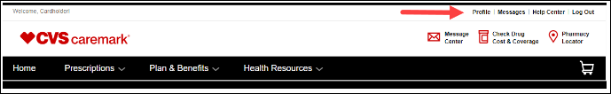

1. Click **Payment Methods** on the left.

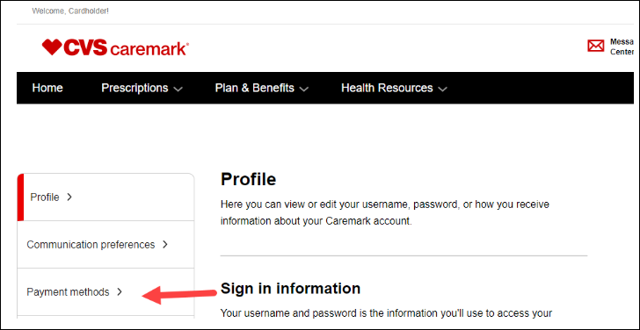

1. The member will be able to enter a credit card or bank account for payment. After the information is entered, the member will press **Save and continue**.

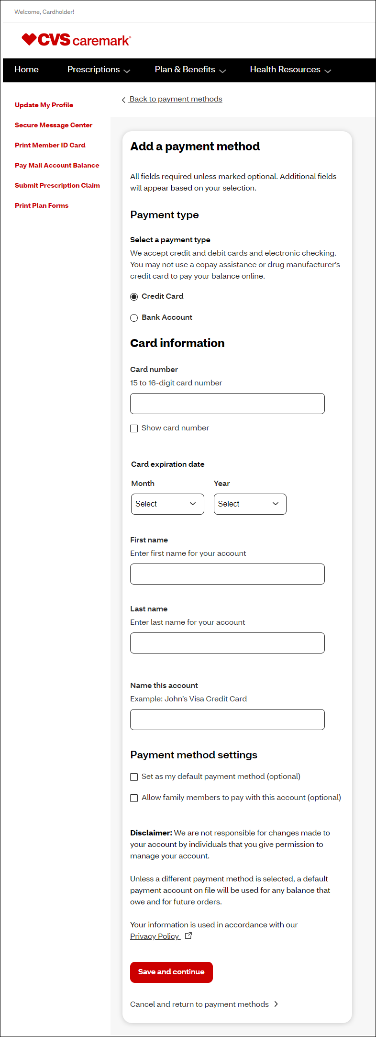

|  |
| --- |
| **SilverScript Premium Payments (Medicare D)** |

Members **MUST** go to **AetnaMedicare.com** to pay their premiums through InstaMed.

1. Select **Pay PDP Premium**.

1. Members are are advised they are leaving **AetnaMedicare.com** for **InstaMed.com.** Click to select **Pay now.**

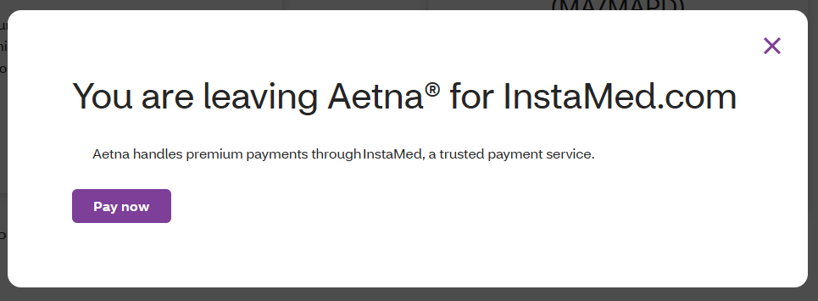

1. Members can Log In, Sign Up, or Make a Payment by entering their Email, Payment ID, Birth Date, and Zip, then select **Pay Now**.

|  |
| --- |
| **Related Documents** |

[Caremark.com - Common Member Assistance Call Types Index](https://thesource.cvshealth.com/nuxeo/thesource/#!/view?docid=947b0b38-401d-4b18-a08e-60348558a9b9)

**Full Details Document:**  [Caremark.com - Account Balance and Payments](https://thesource.cvshealth.com/nuxeo/thesource/#!/view?docid=e6c30ce7-caf7-4c75-96e7-ada6ab0731e3)

**Full Details Document:**  [Caremark.com - Payment Options](https://thesource.cvshealth.com/nuxeo/thesource/#!/view?docid=dcbe2368-ea4d-4371-8171-302498cff3fe)

Not To Be Reproduced Or Disclosed to Others Without Prior Written Approval

**ELECTRONIC DATA = OFFICIAL VERSION / PAPER COPY = INFORMATIONAL ONLY**